2. Git-HOL

2. Create a “.log” file and a log folder in the working directory of Git. Update the .gitignore file in such a way that on committing, these files (.log extensions and log folders) are ignored.

· Setting up Git environment
· Integrate notepad++ as a default editor
· A Git repository in the local system and a remote repository in GitLab

Output

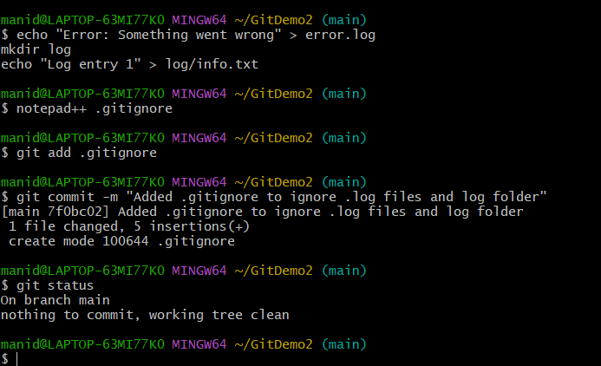

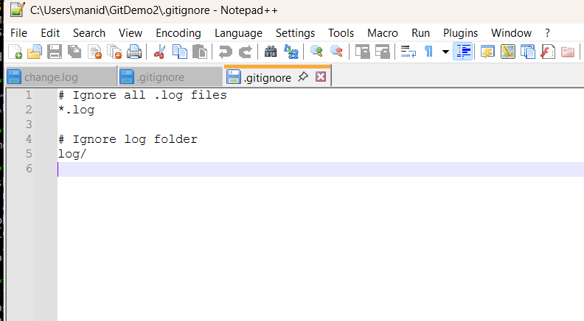d log folders) are ignored

